**Chapter 11 HHE: Oldowan Toolmakers n Stuff**

**Adam Purvis**

**The Oldowan Toolmakers**

- Early hominins 🡪 tool users, because tool use in common in apes

- Orangutans use sticks to pry open fruits, gorillas use sticks to probe depth of water as they come across swamps, chimps use sticks to extract termites from their mounds

**Stones as a tool, The “Oldowan Tool Industry”**

- Early hominins used naturally occurring stones as tools, and then began to modify them

- Researchers have found animal bones marked by stone tools from 3.4 mya 🡪 used to scrape flesh off bones of animals

- By 2.3 mya, hominins were using and producing stone tools such as flakes (small, sharp chips)m cores, hammer stones and debris from manufacturing

- Rounded stones that have been flaked a few times to produce an edge.

- An example of **Mode I Technology**

- We don’t know which hominins were responsible for making the tools

- The first Oldowan toolmaker very well could have been a member of the genus Homo.

- Seemed to be mainly tools for right-handed stuff

**Food Types**

**Collected foods**

- Simply collected from the environment and eaten. Includes ripe fruit, leaves

**Extracted Foods**

- Don’t move but are protected in some way. Fruits in hard shells, tubers or termites buried deep underground, etc

**Hunted Foods**

- Things that run away and must be caught and or trapped. May need to be extracted and processed before consumption. Vertabrae prey are a good example of this.

**Complex Foraging Strategies in Humans**

- Apes are “brainiacs” when it comes to foraging; gorillas and orangutans use elaborate routines to access some plant foods. Both orangutans and apes use tools of some kind to process foods.

- Humans depend on hard-to-learn skills for food consumption

- **Chimps are overwhelmingly dependent on collected resources, but human foragers get most of their calories from extracted or hunted resources**

- Such hard to learn skills promote a long juvenile period; we must learn a diverse set of hunting skills

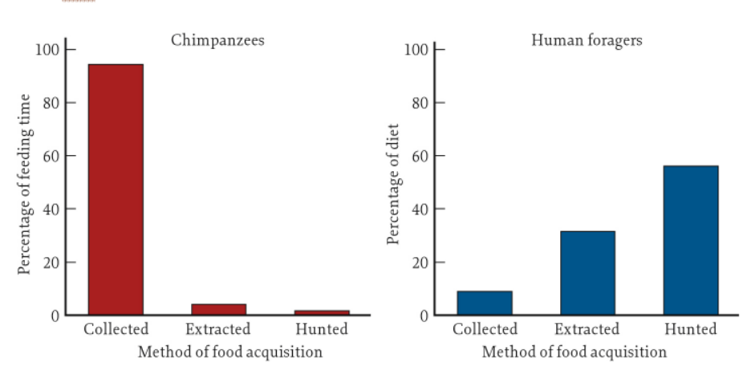- Men = hunting; women = extractive foraging 🡪 specialization and learning the skills is difficult, so it’s better if we have learned roles for each gender to split the work up.

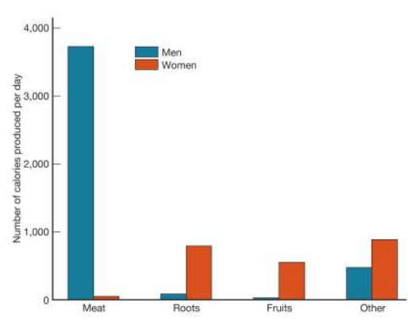

**Food Sharing Within Chimps**

- unlike most primates, chimps will share their food

- mothers plant food with infants, adults sometimes share meat.

- mothers are most likely to share foods that are difficult for the infants to obtain/process independently

- meat sharing 🡪 small prey usually isn’t shared, but large prey is usually shared with other members of the group

**Food Sharing Within Humans**

- Juveniles are consumers - we depend on others for food long after they’re weaned

- Men become self-sufficent at age 17, women don’t become self-sufficient until their forties.

- Middle aged men and postmenopausal women are producers.

**Evolution of Slow Life History**

- Selection may have favored larger brains, a prolonged juvenile period and a longer life span because these traits make it easier to learn complex foraging methods.

- Complex foraging techniques allow humans to acquire valuable or otherwise inaccessible resources.

- Extractive foraging and hunting require intelligence and learning

- If learning is valuable, natural selection will favor adaptations that make a better learner… thus a shift to hunting and extractive foraging would favor larger brains and greater intelligence.

- Learning takes time; so selection favored a longer juvenile period to allow human children time to acquire the skills they needed.

- Food sharing and division of labor lead to reduced competition between males and reduced sexual dimorphism; males do relatively little for their offspring, so selection therefore favors male traits that enhance their ability to compete with other males for mating

**Complex Foraging in Oldowan Toolmakers**

- Oldowan tools could be used for a variety of tasks, including the butchering of large animals or for digging

- Wear patterns on bone tools from south Africa indicate that they were used to excavate termite mounds

- Extractive foraging, commonly done with wooden digging sticks by modern people 🡪 likely to leave fewtraces in the archaeological record.

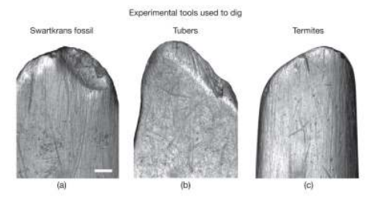

**Evidence for Meat-Eating**

- Sites with lots of animal bones also had numerous stone artifacts such as hammers, anvils, cores, flakes and battered rocks.

- Manufactured from rocks that came from the rocks in the area

- Despite this the association of hominin tools and animal bones does not necessarily mean that early hominins were responsible for these bone accumulations 🡪 bones could have accumulated at the sites without any help from humans

**Palimpsites**

- Sites where humans visited after bones had accumulated and left their tools

**Taphonomy**

**-** the study of what happens after death

- Examine spots where animals have been killed, processed, eaten… monitor predators and prey

- Examine marks left on bones when they have been chewed on, processed with tools, or left out in the open for long periods of time.

**Olduvai**

- At the olduvai sites where both animal bones and tool have been found, taphonomic analyses have shown the most bones were not accumulated by natural processes

- Instead, analyses suggest that hominins were at sites and made cut marks

- other sites show the involvement of carnivore activity, perhaps hyenas.

**Hunting or Scavenging?**

-**In general - Hunting 🡪 tooth marks on top of cut marks. Scavenging 🡪 cut marks on top of carnivore tooth marks**

- Eating meat does not necessarily imply hunting.

- Hominins were too small to kill, so maybe they scavenged? They probably did both.

- Scavenging can be as difficult and as dangerous as hunting.

- Carnivores practice both hunting and scavenging.

- Studies show that bone cut marks and carnivore tooth marks indicate that all bone types that are found at olduvai and humans might have stolen kills from carnivores (Fucking KSers)

**Domestic Lives of Oldowan Toolmakers**

- Approx 1.9mya

- Most oldowan hominin foraging people establish a temporary “home base” camp. Food is shared, processed, cooked and eaten here. A universal trait

- Weave nets, manufacture arrows, tools and whatnot

- Dense accumulation of stones in areas not home bases due to:

- Hominin and nonhominin carnivores were active at many olduvai sites… some bones only show marks of non hominin carnivores

- Homnins and nonhominin carnivores competed over kills. The bones of nonhomnin carnivores occur much more than would be expected on the basis of their occurrence in other fossil assemblages

- Modern kill sites - the scene of violent conflict among carnivores

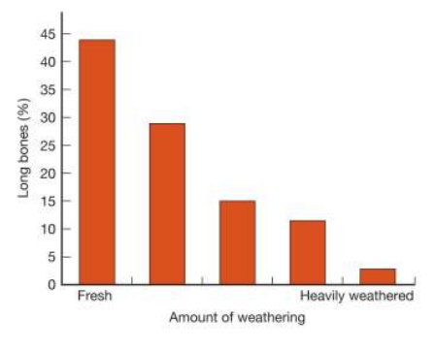- Sites don’t show evidence of intensive bone processing.

- Bones accumulated at Olduvai are weathered…